Lab 2-2. Conditional Statements
Lab 2-2. Conditional Statements 1
1.1. Create a PHP project 2
1.2. Conditional Test Example 2
1.3. Using switch statement 5
1.4. Square and Cube 6
1.5. Date Time Processing Exercise 9

Create a PHP project
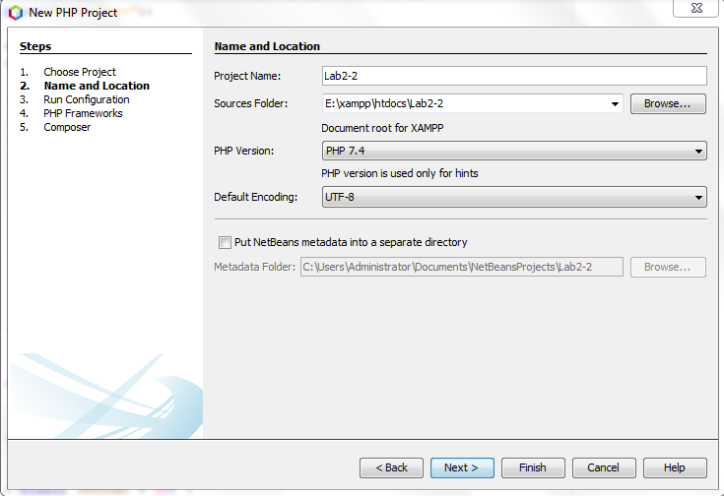

Conditional Test Example

Create ConditionalTest.html
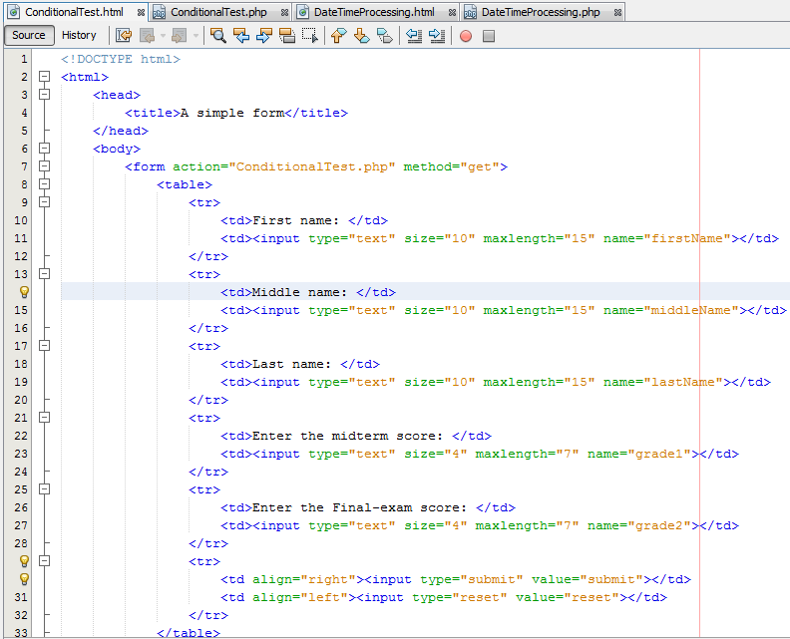

Create ConditionalTest.php
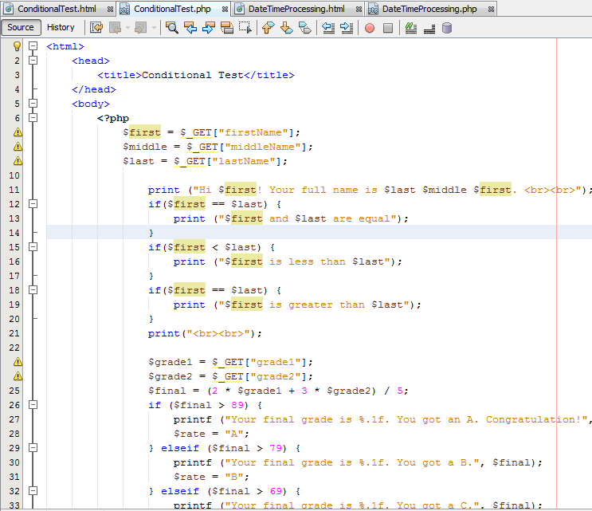

Run the ConditionalTest.html
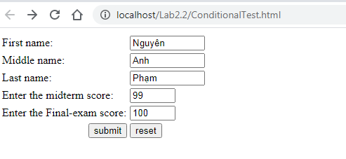

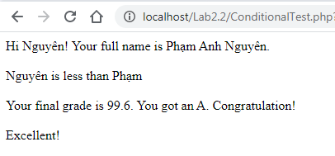

Using switch statement
Modify the ConditionalTest example as the following. Run and observe the result.
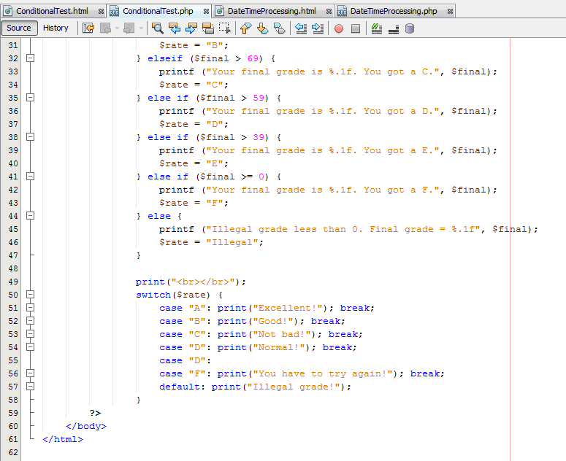

Square and Cube

Create a SquareCube.php file to generate square and cube values.

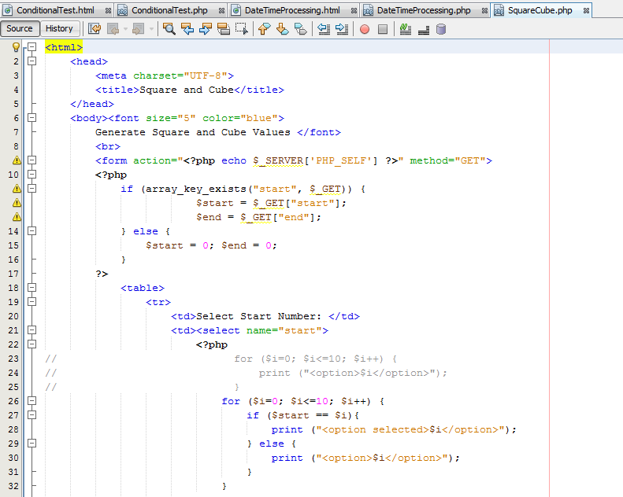

Run and observe the result

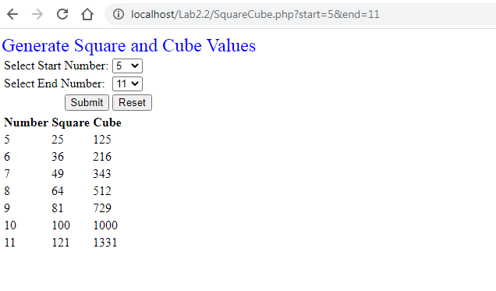

Date Time Processing Exercise

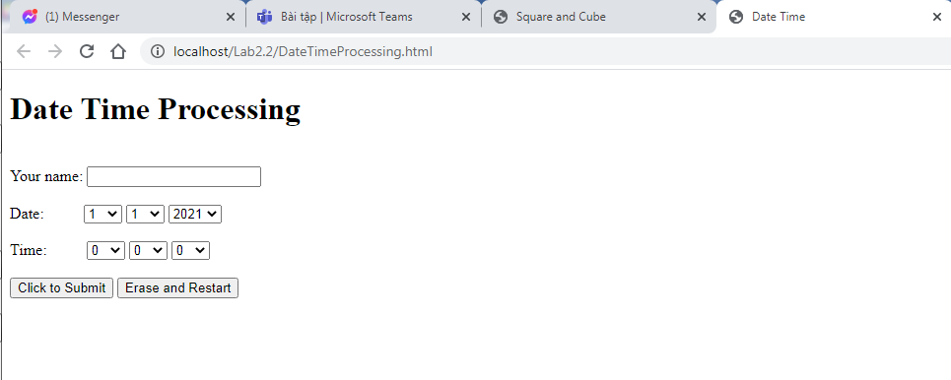
Năm thường:
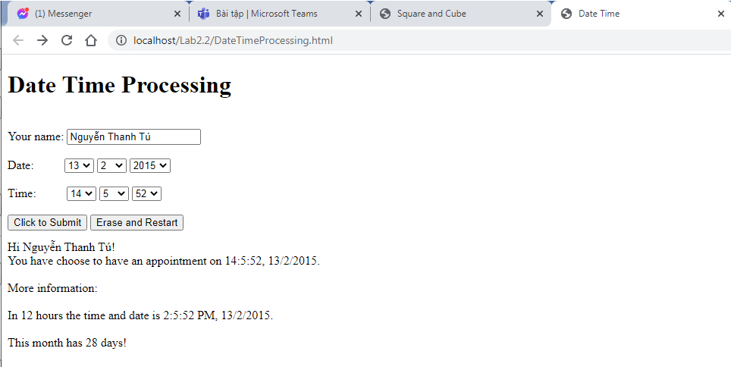

Năm nhuận:
